Bahria University,

Karachi Campus

LAB EXPERIMENT NO.

**07**

LIST OF TASKS

|  |  |
| --- | --- |
| TASK NO | OBJECTIVE |
|  |  |
| 1 | Write a program in MIPS assembly language that takes input from user and print whether the input is greater or less than 10 and also shift input left and right 4 bits |
| 2 | Take two number from user and print which number is greater (Example). |
| 3 | Take two number from user and print sum and subtraction. |

Submitted On:

16/11/2022

(Date: DD/MM/YY)

**TASK NO 1**:Write a program in MIPS assembly language that takes input from user and print whether the input is greater or less than 10 and also shift input left and right 4 bits

.data

**OUTPUT**:

num1: .asciiz "Enter any Number :"

p:.asciiz "After shift left 4 bits "

q: .asciiz "After shift right 4 bits"

.text

main:

la $a0,num1

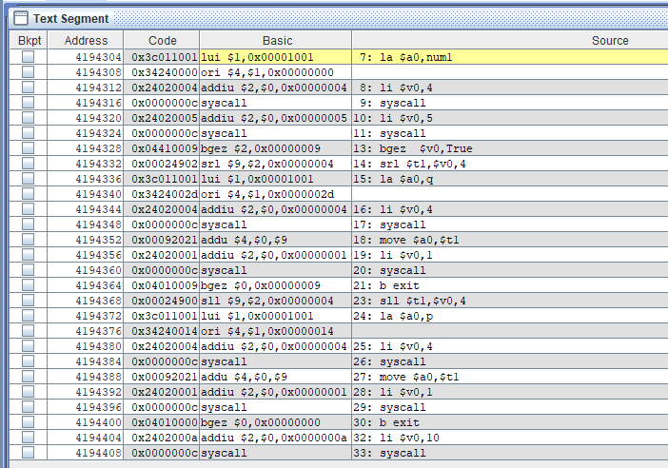

li $v0,4

syscall

li $v0,5

syscall

bgez $v0,True

srl $t1,$v0,4

la $a0,q

li $v0,4

syscall

move $a0,$t1

li $v0,1

syscall

b exit

True:

sll $t1,$v0,4

la $a0,p

li $v0,4

syscall

move $a0,$t1

li $v0,1

syscall

b exit

exit:

li $v0,10

syscall

**EXAMPLE**: Take two number from user and print which number is greater (Example).

.data

a:.asciiz "The First Number :"

b:.asciiz "The Second Number :"

c:.asciiz "First Number is greater :"



d:.asciiz "second Number is greater :"

.text

la $a0,a

li $v0,4

syscall

li $v0,5

syscall

move $t0,$v0

la $a0,b

li $v0,4

syscall

li $v0,5

syscall

move $t1,$v0

bgt $t0,$t1,True

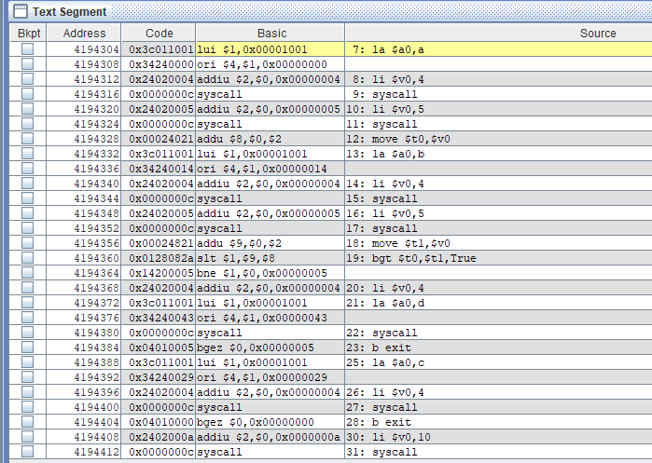

li $v0,4

la $a0,d

syscall

b exit

True:

la $a0,c

li $v0,4

syscall

b exit

exit:

li $v0,10

syscall

**Task no 1:**Write a program in MIPS assembly language that takes input from user and print whether the input is greater or less than 10 and also shift input left and right 4 bits

**INPUT**:

.data

num1: .asciiz "Enter any Number :"

mess: .asciiz "Number is Less than 10 :"

mess1: .asciiz "Number is Greater Than 10:"

mess2: .asciiz "Number is equal To 10 :"

.text

.globl main

main:

**OUTPUT**:

addi $t1,$zero,10

li $v0,4

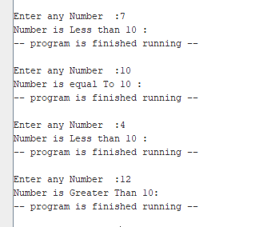

la $a0 ,num1

syscall

li $v0,5

syscall

move $t0,$v0

slt $t2,$t0,$t1

beq $t0,10,equal

beq $t2,0,if

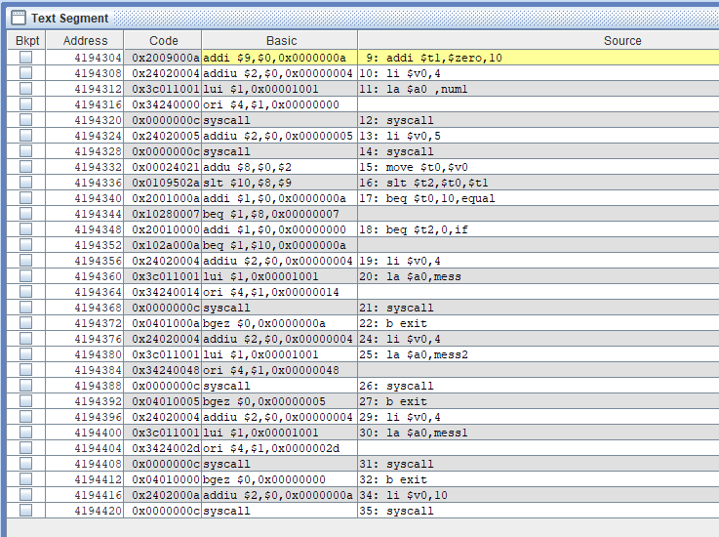

li $v0,4

la $a0,mess

syscall

b exit

equal:

li $v0,4

la $a0,mess2

syscall

b exit

if:

li $v0,4

la $a0,mess1

syscall

b exit

exit:

li $v0,10

syscall

**EXAMPLE**

.data

promp1: .asciiz "Enter Num1 :"

promp2:.asciiz "Enter Num2 :"

sumres:.asciiz "The result of addition : "

subres:.asciiz "\nThe result of subtraction :"

res:

.text

.globl main

main:

la $a0,promp1

li $v0,4

syscall

li $v0,5

syscall

move $t0,$v0

la $a0,promp2

li $v0,4

syscall

li $v0,5

syscall

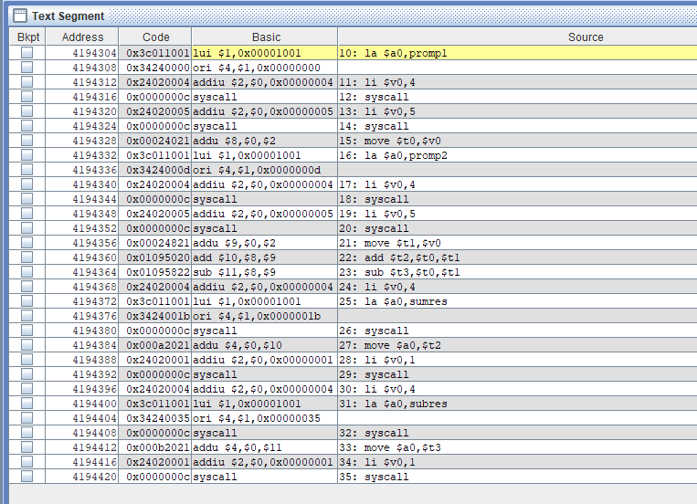

move $t1,$v0

add $t2,$t0,$t1

sub $t3,$t0,$t1

li $v0,4

la $a0,sumres

syscall

move $a0,$t2

li $v0,1

syscall

li $v0,4

la $a0,subres

syscall

move $a0,$t3

li $v0,1

syscall

**OUTPUT:**

